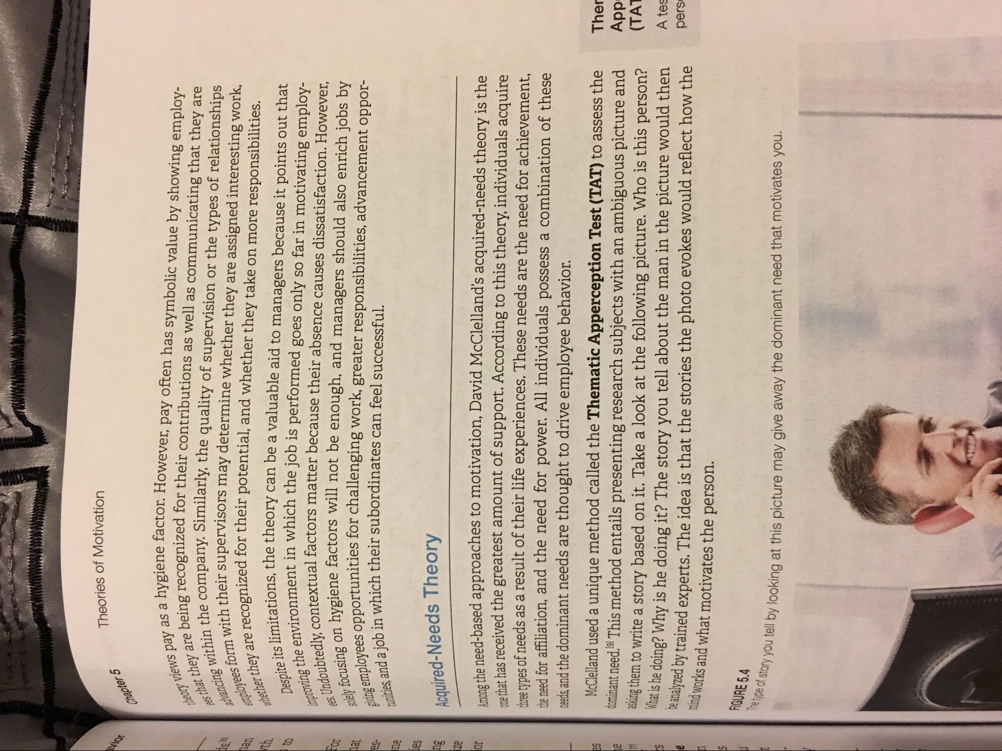
Theories of Motivation
Chapter 5
heory views
hat they are being recogr
advancing within the employees form with the
whether they are recognized
Despite its limitations improving the environmer ees. Undoubtedly, contextual f solely focusing on hygiene fa giving employees opportunit tunities, and a job in which
na a hygiene factor. However, pay often has symbolic value by showing employ
ng recognized for their contributions as well as communicating that they are the company. Similarly, the quality of supervision or the types of relationships ith their supervisors may determine whether they are assigned interesting work, ecognized for their potential, and whether they take on more responsibilities. itations, the theory can be a valuable aid to managers because it points out that vironment in which the job is performed goes only so far in motivating employcontextual factors matter because their absence causes dissatisfaction. However, nhygiene factors will not be enough, and managers should also enrich jobs by Pas opportunities for challenging work, greater responsibilities, advancement opporwh in which their subordinates can feel successful.
or
DOI
Acquired-Needs Theory
the need-based approaches to motivation, David McClelland's acquired-needs theory is the no that has received the greatest amount of support. According to this theory, individuals acquire three types of needs as a result of their life experiences. These needs are the need for achievement, the need for affiliation, and the need for power. All individuals possess a combination of these needs, and the dominant needs are thought to drive employee behavior.
McClelland used a unique method called the Thematic Apperception Test (TAT) to assess the dominant need. This method entails presenting research subjects with an ambiguous picture and asking them to write a story based on it. Take a look at the following picture. Who is this person? wat is he doing? Why is he doing it? The story you tell about the man in the picture would then e catalyzed by trained experts. The idea is that the stories the photo evokes would reflect how the mind works and what motivates the person.
Ther App
(TAT
A tes
pers
FIGURE 5.4 The type of story you tell by looking
ou tell by looking at this picture may give away the dominant need that motivates you.

